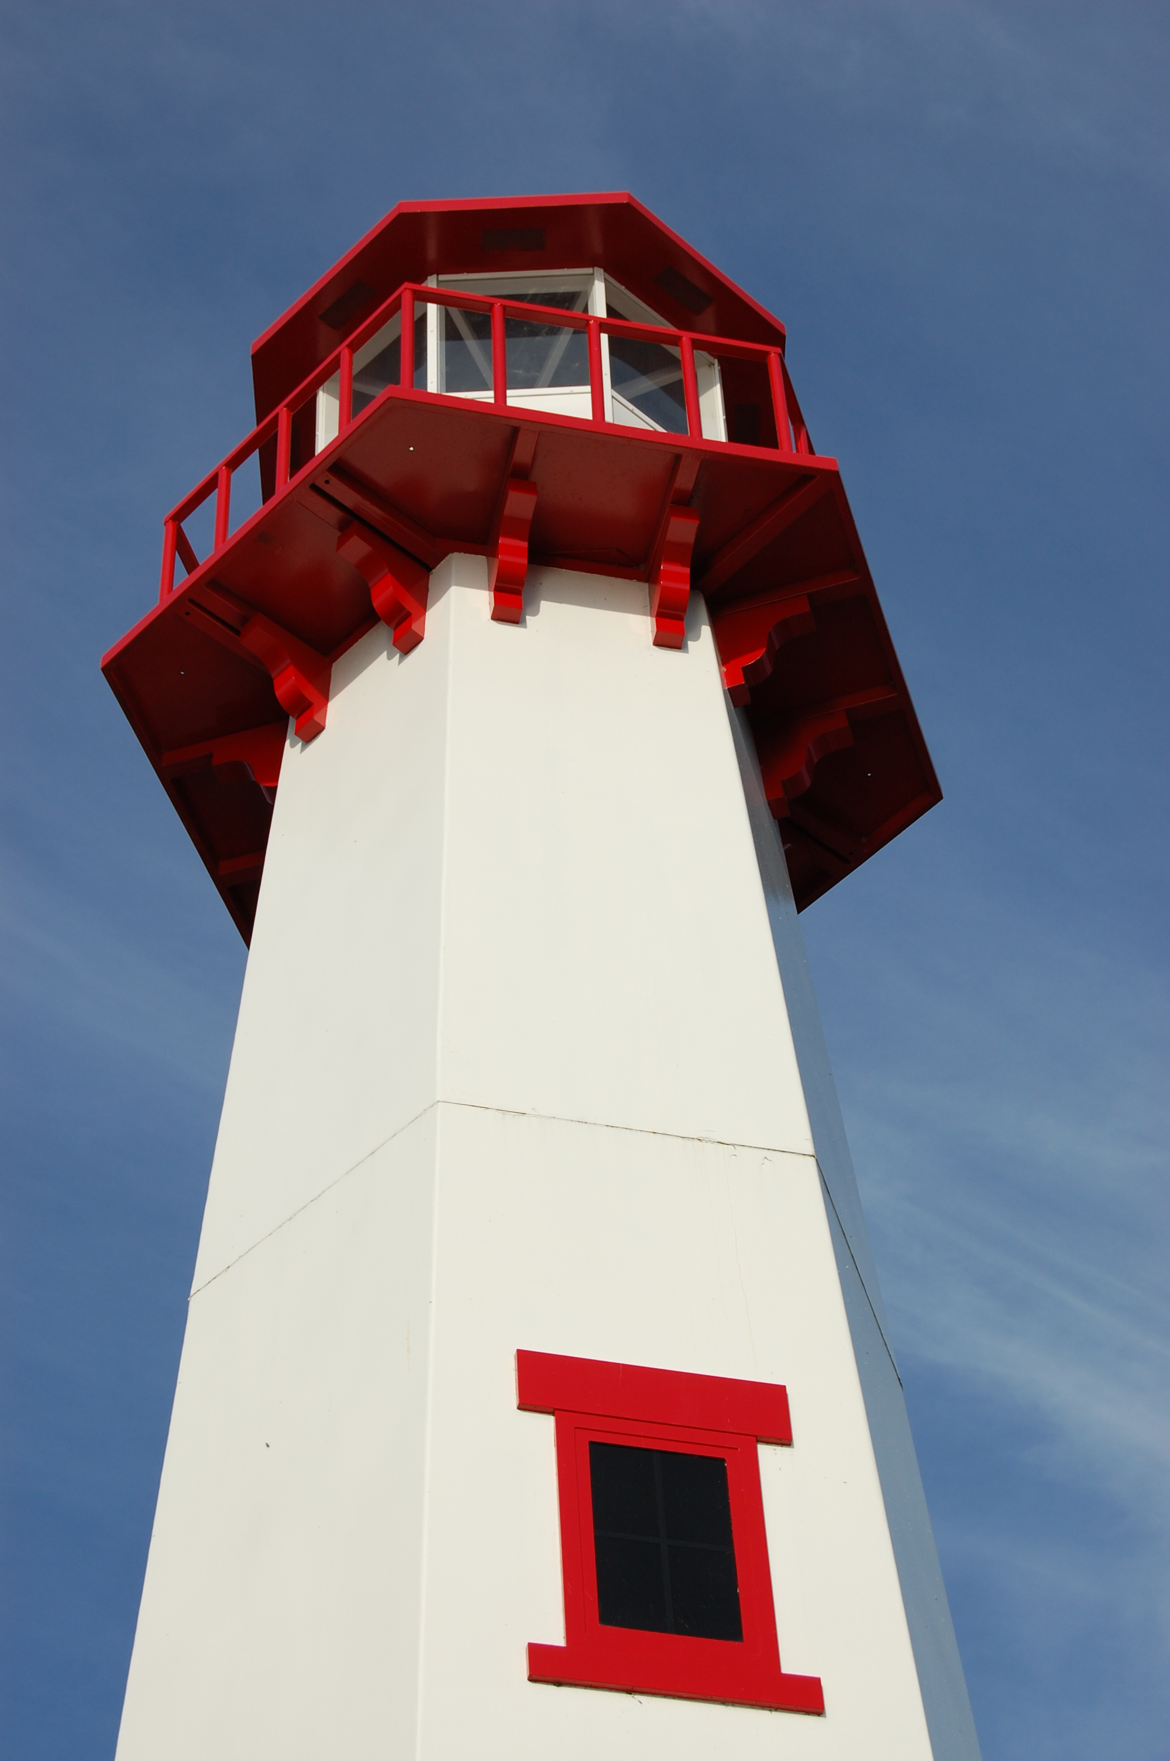
THE LIGHTHOUSE

Newsletter for November 2016

In him was life, and that life
was the light of men.
John 1:4

Message from Our Pastor

Dear Sisters and Brothers in Christ,

A few weeks back I gave a sermon titled “I’m Grateful” and as I sit here typing my second November newsletter article as your pastor, I really mean that from the bottom of my heart! I’m Grateful to have been called here to serve Zion and Trinity. We have much to be thankful for as we journey into the season where we celebrate Thanksgiving. Your generous giving has helped us avoid using money from the endowment fund, we have had great attendance in both Zion and Trinity bible studies. We had our first NOIZ event where we had 14 youth in attendance from both Zion and Cedarville! And we can’t forget confirmation and Sunday school has kicked off with a wonderful start too. The Sisters of Zion are hitting the ground running with the Pasty sales which is something I’m really looking forward too, and the Ladies at Trinity will be making bread baskets welcoming those in the community to come and see what the Holy Spirit is doing there.

With all of this happening I’m Grateful and I give thanks for all those who have given so much to our community of faith, in the gifts God has blessed them with! Thank-You! I also want to say Thank-You for all the prayers not only for me but for our communities of faith, keep those prayers coming and together through the Holy Spirit we will continue to do wonderful things in the name of Christ.

May your Thanksgiving be filled with love and Joy!

Yours in Christ,
Pastor David

Newsletter

The Newsletter was not adopted this month. ☹

All Saint’s Day

November 1st is All Saint’s Day. This is a day in the church when we remember all the baptized who’ve gone before us. In the past year, we have buried the following saints:

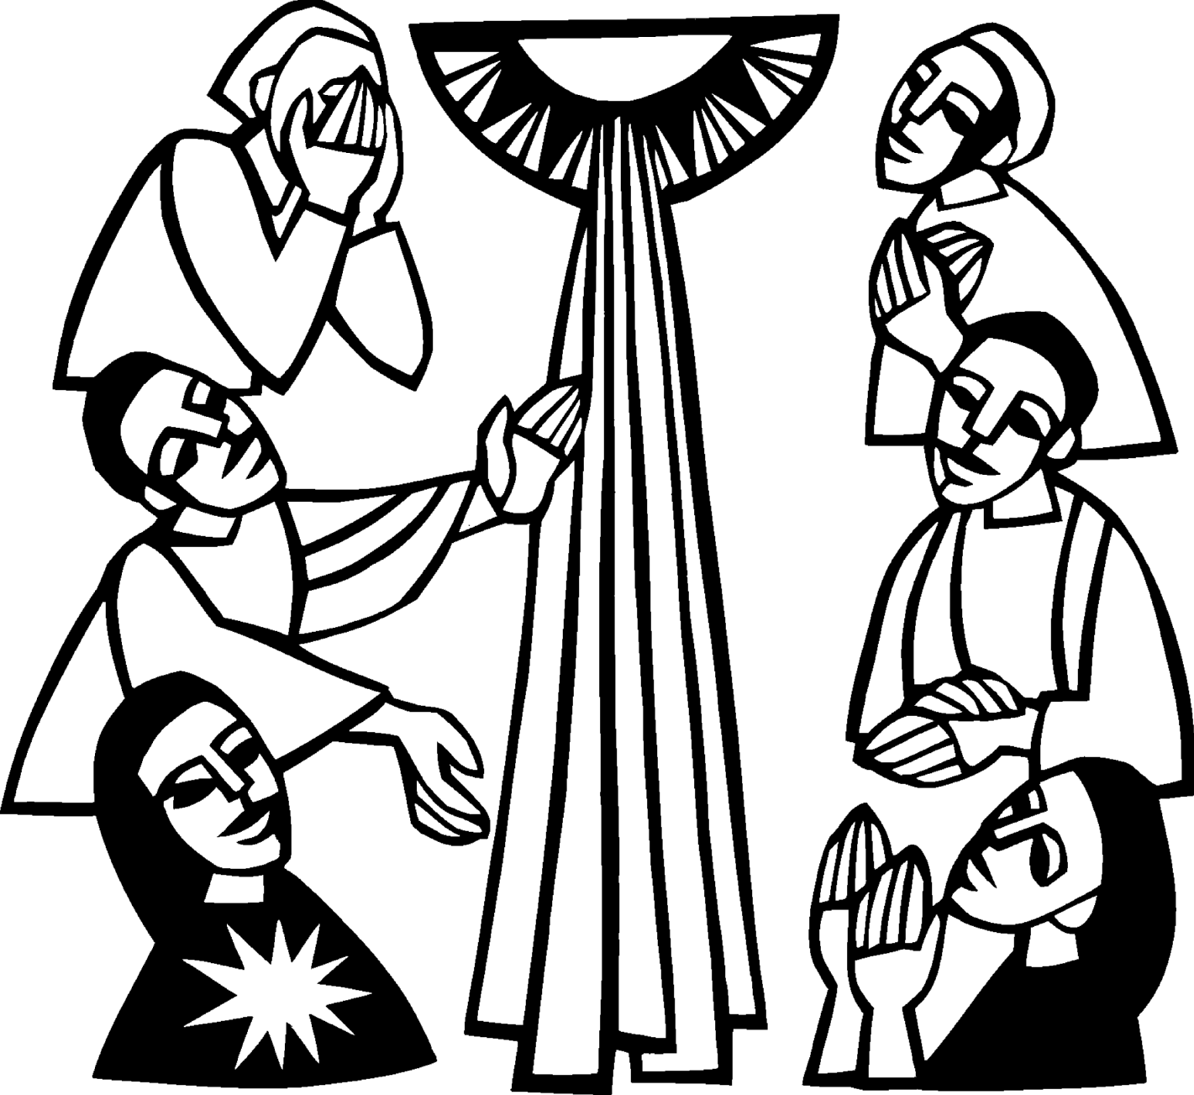
Jim Dyer
Tom Schenkel
Phil Richel
Maureen Malone
Helen Nakarado
Gloria Marshall
Carl Belonga
Randy Kaminsky

Noisy Offering

The noisy offering for November 6th will go to The Food Pantry. Need is always greater at this time of the year.
Calendar Note

Daylight Savings Time changes on November 6th. Turn your clocks back. Smoke detector batteries should be replaced at least once a year. People often change them when the clocks change.

Sunday School

We will have Sunday School for all children, Preschool – 5th grade, during the 11 am service at Zion (except for the last Sunday of the month).

NOIZ

The NOIZ Youth Group will be going to a gathering in Cedarville on November 6th.

This event is for 12 - 18 year-olds. Bring a friend or 2 or 3. The more the better!

Adult Bible Study

Adult Bible Study will be most Wednesdays at 7 pm. (The third Wednesday is Zion Council) Please join us in the Zion Family Center!
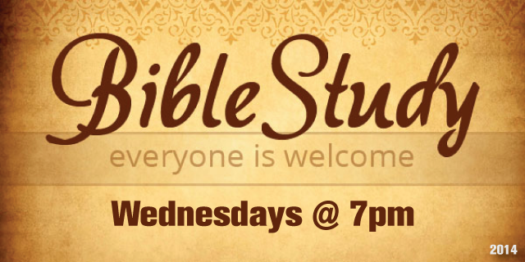

Confirmation Meeting

Confirmation will be on the 2nd Sunday of each month from 5 – 7 pm. This month will be on November 13th.

Pasty Sale

On November 12th & 13th from 10 am to 4 pm, we will be selling frozen pasties at McDonald’s parking lot for hunters needing a quick and easy meal. We will be selling them again the next weekend if there are any left. We will need volunteers to help sell them. They will be chicken or beef for a donation of $5 each, 3/$14, 6/$26, or 12/$48.

Advent is Coming!

We will be decorating the church for Advent, following the service on Sunday, November 20th. Please help out if you can.

Community Thanksgiving

We will be having a Community Thanksgiving Service at Zion on Sunday, November 20th at 7 pm. All are welcome to join us in giving thanks for all of our blessings.

Family Fun Night

November 27th from 4 - 6 pm is Zion Family Fun Night. Join us for food, fun, games, and fellowship.
Baptismal Anniversaries

November 2 Joshua LaJoice
November 12 Misti Gamble
November 13 Tim Idalski
November 14 Adrian Coleman

November 14 Madison Coleman
November 17 Kristen Olsen
November 21 Duane Gamble
November 25 LaRoy Hill
November 27 Mike Wilkins
November 27 Mandy Fenlon

Birthdays in November

November 3 Tim Idalski
4 Ernie Vallier
4 Linda Wilkins
7 Rita LaVake
11 Kathy Marshall
11 Samantha Wyers
12 Shirley Winberg
15 Nancy Hardy
15 Alicia LaLonde
17 Faith Gaubault
17 Wyatt Huhn
17 Kyra Spencer
18 Lori Bowlby
19 Connie Olsen
19 Justin Stenson
22 Lisa Gamble
23 Shirley Campbell
25 Dawn Akers
26 Misti Gamble
29 Jessie Rogers
Prayer List

(If you would like someone added to the prayer list, please call or email the church)


Mary Belonga, Dave & Lois Movalson, LaTaunya Paquin, Barb Lehto, Charlie Lamoreaux, Ed Idalski, Luanne Keinonen, Joel Morabito, Judy Schlehuber Bridges, Jackie Rippit, Tom & Taffy Coffey, Ed Heenan, Bev Kammers, Eric Rose, Charles Beeck, Phillip Brooks, Joe & Sharon Chalmers, Joanne Tamlyn, Bethany Wiese, Nadine Dandona, Patty Thibault, Jim Rose, Gayle Kaminsky Pande, Alfie Dyer, Christine Scott, Charlie Dowd, Virginia Gustafson, Kelly Perrault, Rick Brown, Karen Fowler, Danielle Becker, Delores Marshall, Rod Novenske, Corina Clark, Bill & Sandy Tielbar, Rick and Kirk

Zion Funeral Committee Aug - Nov

Team Leader: Linda Wilkins (430-1465)
Co-leader: Rita LaVake (906) 298-0005

Trinity Worship Families

Nov 6 Movalson Family
Nov 13 Baron Family
Nov 20 Chalmers Family
Nov 27 Rose Family

Servants for Zion

Ushers & Greeters
Nov 6 Sam LaVake Family
Nov 13 Confirmation Youth
Nov 20 Amy Dodds Family
Nov 27 Mark & Carol Elmblad

Lectors
Nov 6 Paul Shepard
Nov 13 Judy Ryerse
Nov 20 Lorraine Graham
Nov 27 Richard Galor

Acolytes
Nov 6 Josh Feleppa
Nov 13 Brendan Insley
Nov 20 Ellie Tielbar
Nov 27 Bailey Ryerse

Communion Assistants
Nov 6 Lana Lennington
Nov 13 Karen Schlehuber
Nov 20 Steve Christiansen
Nov 27 Jerry Fenlon

Altar: Karen Schlehuber
Money Counters: Dena Barker and Donna Harju

The Usher duties are:
- Arrive 30 minutes before church
- Pass out bulletins and welcome guests
- Help with the offering and communion
- Record attendance

We will be providing the Long Term Care Service on November 20th. Please help out if you can.
Council Meetings

Trinity Council – 6 pm, November 15th
Zion Council – 6:30 pm, November 16th

Zion’s Council Members
President: Lana Lennington 643-6576
Vice-President Paul Shepard 984-2069
Co-Treasurers: Dawn Akers 643-7552
Co-Treasurers: Lana Lennington 643-6576
Secretary: Steve Christiansen 298-1051
Mary Christiansen 235-6123
Jerry Fenlon 643-8730
Tim Idalski 643-6574
Karen Schlehuber 643-0311

Trinity’s Council Members
President: Jerri Rose 292-5570
Vice-President Tracy Movalson 292-5581
Secretary: Sharon Chalmers 292-5440
Treasurer: Pega Kennedy 292-5633
Co-Treasurer: Jim Rose 292-5570
Financial Secretary: Tom Gustafson 292-5460
WELCA: Pega Kennedy 292-5633
John Kennedy 292-5633
Lois Movalson 292-5581

Treasurer's Report for Zion
January 1, 2016 through October 22, 2016
Income:
 | Amazon Smile Foundation | 15.45
 | Building | $ 1,200.00
 | Church Use Income | $ 391.00
 | General | $ 64,636.65
 | Thrivent Financial Income | $ 44.00
 | Trinity Share | $ 13,091.61
 | TOTAL |  | $ 79,378.71
Expenses:
 | Administration | $ 4,886.30
 | Benevolence | $ 1,875.00
 | Church Maintenance | $ 10,618.56
 | Education | $ 265.78
 | Parsonage Maintenance | $ 2,598.53
 | Pastoral | $ 50,533.02
 | Worship | $ 4,319.65
 | --To Building Fund | $ 1,120.00
 |  |  | $ 76,216.84
 |  |  | 3,161.87
***********************************************************
Thrivent Financial Investment Fund |  |  | $ 270.25
General fund balance: |  |  | $ 2,328.70
Kitchen/Building Fund balance |  |  | $ 1,987.19
General fund owes building fund: |  |  | $ 80.00
General fund owes Mission Endowment fund: |  |  | $ 7,995.00

Zion Lutheran Council Meeting
October 19, 2016

Council Members Present: Pastor Dave, Karen, Jerry, Lana, Mary, Steve.

Lana called the meeting to order at 6:35.

Pastor Dave opened with devotions and prayer from "Perfecting the Church” written by Martin Luther in 1544.

1. Pastor's Report:

A. Charter Cable will be here on October 20 to install new internet service for the church.

B. NOIZ is going well with 12 kids present at last gathering, including some from Cedarville. NOIZ will continue to work with Cedarville on scheduling mutual events both at Zion and in Cedarville.

C. Confirmation is up and running and going well.

D. Pastor outlined a new communion procedure where the elements of communion will be brought from the back of the church to the altar by the ushers. We will start this the first Sunday in November on a trial basis.

E. A Stewardship Committee will be formed soon. See Pastor, Lorraine, or a Council member if you are interested in serving on the committee.

F. November 13-15 are the dates for first call Pastors theological education. Pastor Dave will be attending.

G. The Bishop will be at Zion for Reformation Sunday (October 30).

2. Secretary's Report:

Secretary's report was reviewed and approved.

3. Treasurer's Report:

Treasurer's report was discussed and approved.

4. Old Business:

A. Pasty sales costs are covered for 400 pasties. 11 volunteers will meet Saturday, October 22, at 9 a.m. to prepare the pasties. Pasties will be sold at the McDonald's parking lot on Saturday November 12, to hunters heading to camp. A decision was made to sell pasties only, soup had too many issues.

B. WELCA report that they have a $500 balance.

C. The elevator is still not working. Steve will call Kone elevator to discuss their terms of service and see if they have potential to provide service and maintenance at a reasonable price.

Next Council Meeting was scheduled for Wednesday, November 16, at 6:30 p.m.

Meeting ended with the LORD'S Prayer at 7:30 p.m.

Respectfully submitted,
Steve Christiansen

Contact Information

Pastor David Tielbar may be reached at 906-984-2051 or at david.tielbar6@gmail.com. In an emergency, you can reach the Pastor’s cell phone at (563) 880-4512

Church telephone: 906-643-7870 - Answering machine
The secretary will usually be in the office on Tuesday and Thursday mornings from 9 – 12

To email the church is: ziontrinity950@yahoo.com
The website is at http://zionstignace.com/home.html
- Find us on facebook at www.facebook.com/zionstignace

Zion Evangelical Lutheran Church and Trinity Lutheran Church are congregations of the Northern Great Lakes Synod and the Evangelical Lutheran Church in America.

Trinity’s Sunday Service is at 9 a.m.
Zion’s Sunday Service is at 11 a.m.

HOPE Chest

The new winter HOPE Chest hours are:
Fri - Mon: Closed
Tues: 10am - 4pm *donation drop-offs 10-4
Wed: Noon - 6pm *donation drop-offs Noon-5
Thurs: 10am - 4pm *donation drop-offs 10-4
Volunteers are needed! Please consider giving of your time and talent to our mission. Our volunteers are vital to the success of the HOPE Chest. There is a wide range of volunteer positions available, during open hours and on Wednesday evenings from 6 - 8 pm to stock shelves. Please stop in to see how you can help or call Cathie Tielbar at 643-7360.
Annual Turkey Dinner

The Annual Turkey Dinner & Craft Sale sponsored by the United Methodist Church will be on Thursday, November 3rd, 5 – 6:30 pm at the LaSalle High School Cafeteria. Adults $10, Kids (5-12) $5, Take-out $11.

Vote!!!

November 8th is Election Day. Get out and vote!

Bake Sale

The Mackinac Animal Aid Association
will be holding a bake sale at Family Fare
on November 12th starting at 9:30 a.m.

Mackinac Co. Children’s Toy Drive

Sunday, November 13th, 8 am - 12:30 pm: There will be a Pancake Breakfast fundraiser at Mackinac Grille. $6 - adults, $4 - 10 years and under. Proceeds to benefit the Mackinac County Children’s Toy Drive.


They will also be sponsoring a sub and bake sale at Family Fare on November 19th from 8 am until sold out. Baked goods by donation. 6” subs are $3.50 each. Individually wrapped ham and cheese or ham, salami, bologna and cheese.

Happy Thanksgiving!

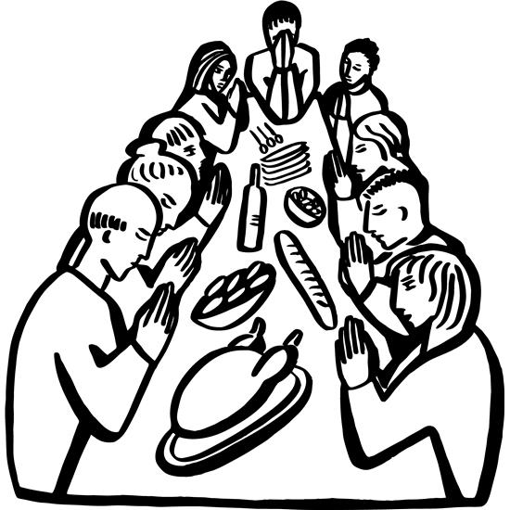

Give thanks to the Lord, for He is good; His love endures forever.
1 Chronicles 16:34

